**Data Analytics Report**

**Objective**

The objective of this analysis is to explore datasets related to user behavior, cooking preferences, and order trends. The goal is to derive actionable insights to improve business performance by examining relationships between user ratings, cooking sessions, order trends, and demographic factors.

**Findings**

**1. Relationship Between Cooking Session Ratings and Order Completion**

* **Correlation:** The correlation between cooking session ratings and order completion was found to be **-0.108**, indicating a weak and slightly negative relationship. High cooking session ratings do not necessarily lead to order completion.
* **Average Session Ratings:**
  + Completed orders: **4.51**
  + Cancelled orders: **4.60**
* **Dish Metrics:**
  + **Dish Name** | **Total Orders** | **Average Duration (minutes)** | **Average Rating**
    - Caesar Salad: 3 orders, 21.67 minutes, 4.37 rating
    - Grilled Chicken: 4 orders, 42.50 minutes, 4.78 rating
    - Oatmeal: 1 order, 10.00 minutes, 4.10 rating
    - Pancakes: 2 orders, 30.00 minutes, 4.40 rating
    - Spaghetti: 4 orders, 35.00 minutes, 4.63 rating
    - Veggie Burger: 2 orders, 20.00 minutes, 4.35 rating
* **Inference:** Among dishes, Grilled Chicken and Spaghetti have higher ratings and durations, indicating user satisfaction with these dishes.

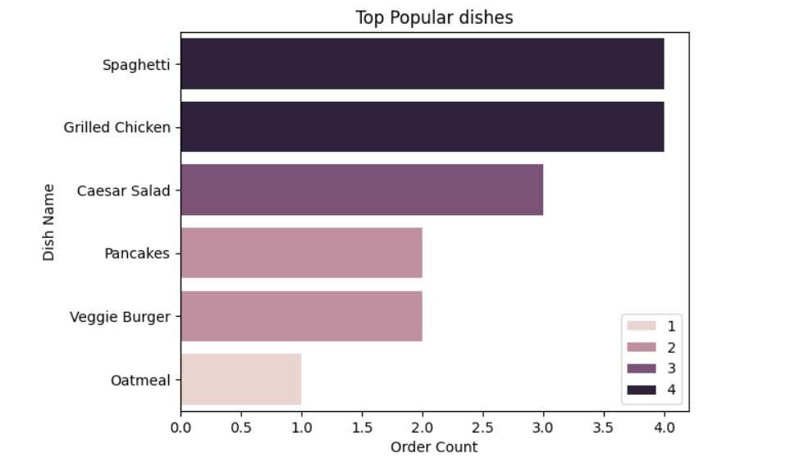

**2. Session Duration and Order Completion**

* **Correlation:** The correlation between session duration and order completion was **0.01**, showing almost no relationship between session length and whether an order is completed or cancelled.
* **Average Session Duration:**
  + Completed orders: **30.36 minutes**
  + Cancelled orders: **30.00 minutes**
* **Inference:** Session duration does not significantly influence order completion. Both completed and cancelled orders have similar average durations.

**3. Popular Dishes and Order Trends**

* **Top Dishes by Completed Orders:**
  + Spaghetti: 4 completed orders
  + Grilled Chicken: 3 completed orders
  + Caesar Salad: 3 completed orders
* **Order Trends:**
  + Some dishes, like Caesar Salad and Spaghetti, are more frequently associated with completed orders.
  + Veggie Burger and Grilled Chicken appear in both cancelled and completed categories, suggesting variability in user preferences.
* **Inference:** Spaghetti is the most consistently popular dish for completed orders. A focus on promoting this dish may yield better results.

**4. Demographics and User Behaviour**

* **User Age and Orders:**
  + Users aged **28–35 years** tend to place more total orders, with the highest being 36 orders from a 28-year-old user in New York.
* **Meal Preferences:**
  + **Dinner** is the most favoured meal type, followed by Lunch and Breakfast.
* **Geographic Trends:**
  + Users from larger cities like **Chicago**, **New York**, **San Francisco**, and **Los Angeles** place the highest number of orders.
* 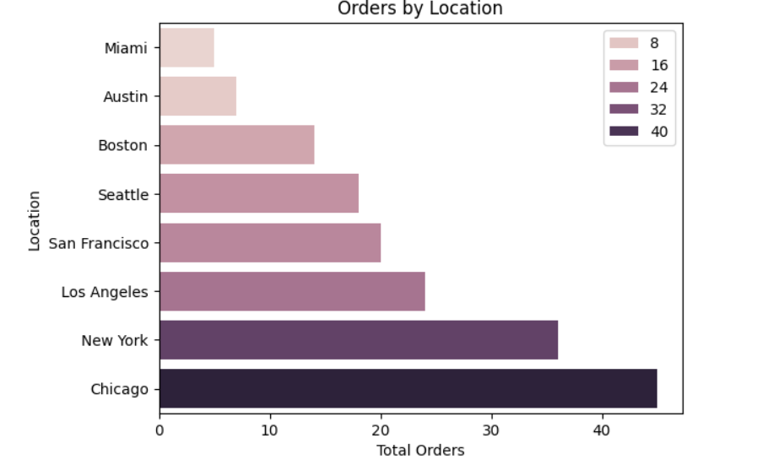**Inference:** Targeting dinner options and focusing on users in large urban areas may improve engagement and sales.

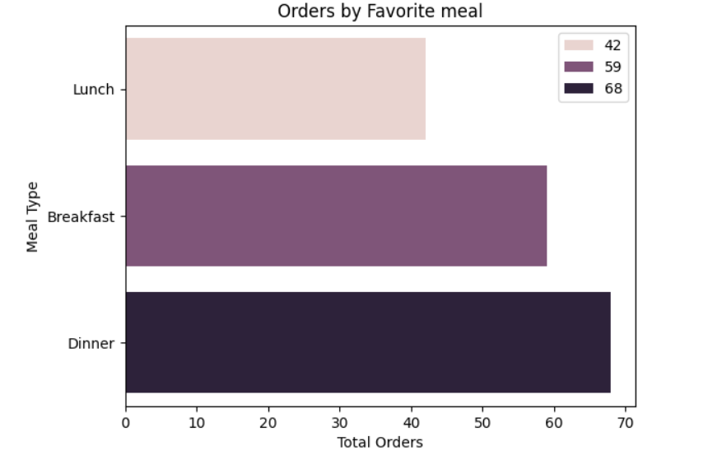

**Business Recommendations**

**1. Focus on Improving User Engagement**

* While session ratings are consistently high, they do not correlate strongly with order completion. Consider:
  + Sending reminders or follow-ups to users post-session to encourage order placement.
  + Offering discounts or incentives immediately after a cooking session to convert high ratings into completed orders.

**2. Promote Popular Dishes**

* Highlight and promote **Spaghetti**, **Grilled Chicken**, and **Caesar Salad** in marketing campaigns, as these dishes have shown higher completion rates.
* Introduce limited-time offers for these dishes to attract more orders.

**3. Tailor Strategies to Demographics**

* Design targeted campaigns for users aged **28–35 years**, as they are the most active order-placing group.
* Focus on locations like **Chicago**, **New York**, **San Francisco**, and **Los Angeles**, where order volumes are highest.
* Prioritize **Dinner** offerings in these campaigns, as this is the most preferred meal type.

**4. Enhance Session and Ordering Experience**

* Analyse feedback from cooking sessions to identify areas for improvement.
* Streamline the ordering process to reduce drop-offs and cancelled orders.
* Experiment with shorter or more interactive cooking sessions, as session duration does not significantly impact order outcomes.

**5. Experiment with New Dishes**

* Test the addition of new dishes similar to Spaghetti and Grilled Chicken in terms of ingredients or preparation style to capitalize on existing preferences.

**Conclusion**

This analysis highlights several opportunities for business improvement, from refining user engagement strategies to tailoring campaigns based on demographics and promoting popular dishes. By implementing these recommendations, the business can enhance user satisfaction and drive higher order completions, ultimately improving revenue and growth.